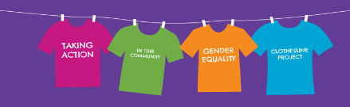
Gender Equality Clothesline Project

Gender Equality Clothesline Project - taking action in our community
The Gender Equality Clothesline Project aims to build on the work already being done by community houses in the outer east.
Led by EACH Health Promotion, in partnership with CHAOS, EDVOS and Knox, Maroondah and Yarra Ranges Councils, community houses are being supported to have conversations with their community to take action on gender equality. Messages developed in this project will be showcased during the 16 Days of Activism Against Gender Based Violence from 25 November to 10 December 2019.

Why are we talking about gender equality?
Simplistic and historical generalisations (stereotypes) about what it is to be male or female can lead to gender inequality.
Gender inequality is a significant contributing factor to violence against women and other forms of violence and discrimination, including family violence, child abuse, homophobia, transphobia, elder abuse, bullying and racism.
In cultures and settings where women are considered ‘less’ than men, violence against women is more likely to occur.
Gender equality does not mean that women, men and gender diverse people need to be the same, but that their rights, responsibilities and opportunities will not depend on their gender.
Our vision is for communities where everyone is valued and enjoys equality of opportunity and outcomes, regardless of their gender.

Gender
The concept of gender is complex and multi-dimensional. It is not as simple as being either male or female.
To begin with, a person’s sex is usually assigned at birth as either ‘male’ or ‘female’ and is based on a person’s biological characteristics.
A person’s gender, on the other hand, may not always exclusively be male or female.
Gender refers to the way a person identifies or expresses their masculine or feminine characteristics.
For some people, their gender may or may not correspond to the sex they were assigned at birth (transgender).
For others, their genetic, hormonal or physical characteristics may not be exclusively ‘male’ or ‘female’ (this is known as intersex).
When talking about gender we acknowledge this term encompasses the diversity of gender, self-identification and sexual identity (lesbian, gay, bisexual, transgender and intersex) that exist in our world today.
Equality and Equity
The image below shows that ‘equity’ is the process required to achieve ‘equality’:
- affirmative measures must be put into place (eg higher boxes to stand on)
- to improve access (eg view of the game);
- to overcome barriers (age, height);
- to ensure inclusion, participation and equal opportunities.
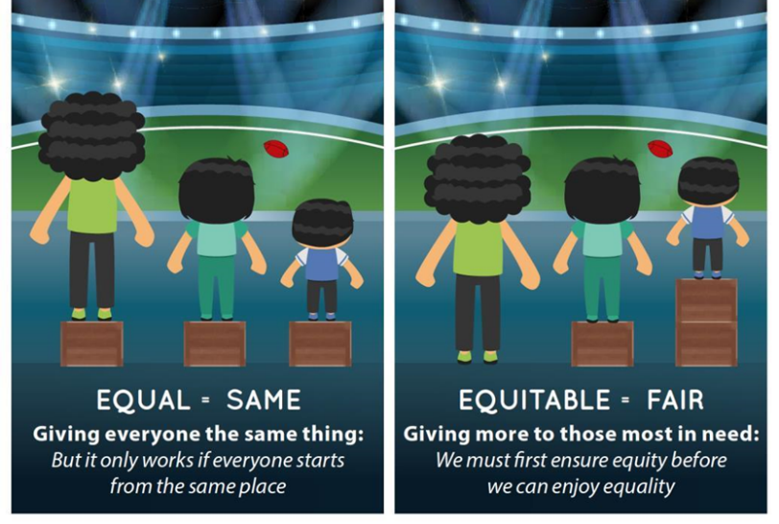
,

Equality = sameness Equity = fairness

What can a gender equal world look like?
- Equal and respectful relationships are the norm
- No violence against women
- More women in leadership roles
- Unpaid work and care responsibilities are valued and equally shared
- Employees are supported to fulfil their potential and have access to flexible work arranges regardless of gender
- Children can be whoever they want to be - they feel equally comfortable playing football or taking dance classes
- Children and young people learn about respectful relationships at school, including consent and equality
- Women are financially independent and secure in retirement and old age
- We can all look back on our lives and believe that gender never constrained our aspirations, opportunities and outcomes.

Thanks to Knox Pledge and Safe & Strong: Victorian Gender Equality Strategy

